Col. Thomas J. Cunningham Jr. Division

President’s Report – February, 9, 2022

BE INFORMED: BE PROUD; BE COMMITTED

Good afternoon Brothers. One of my commitments when I decided to "rerun" for President for OUR Division was to do my best to keep everyone informed as to what is going on as we slowly BUT SURELY learn to cope with COVID and get on with our lives. With that in mind, I wish to bring a few things to your attention that occurred this past month........

The year got off to a rather good start on January 5th when most of OUR newly elected or appointed officers joined on a ZOOM meeting to review my expectations for the coming year. As I mentioned to many of you prior to the elections in December, I accepted the position with the clear understanding that all of OUR Division upcoming activities will be a "shared undertaking" by all Brothers willing to step up and help make the events a success; no longer will events be shouldered by just a few Brothers. So that evening, Officers were given assignments - opportunities in 2022 to grow our AOH Division - for their consideration and implementation. That list is attached to this email as well as an approximate timetable as to when the event will occur. Events and their respective timetable may change as we get into the year. Candidly it is a rather aggressive schedule, but with 100 AOH Cunningham Brothers each stepping up in one way or another over the year, ALL THINGS ARE POSSIBLE! I ask that you review the list and make a point to reach out to the assigned COORDINATOR and let him know of YOUR willingness to help out. Thank you in advance for your support and pro activeness Brothers!

On January 4th, a long awaited dinner with our Chaplain, AOH Brother Fr. Joseph Farrell took place to renew our shared commitments for the AOH. We are very fortunate to have Fr. Joe as both Division as well as State Chaplain for this upcoming year! Fr. Joe has graciously offered the GMU Chapel and grounds for any events we wish to hold. Further, it is our hope to work with the GMU FOCUS organization in promoting Catholic values with the college students both here in Virginia and possibly in Ireland. More to follow in the month’s ahead as we explore how the AOH can effectively assist with this national organization.
On Wednesday, January 12th, I was privileged to accept on behalf of OUR Division this year’s FFAI (Freedom for All Ireland) Plaque from State’s FFAI Director’s Brothers Jim McLaughlin and Terry Riley. Due to the generosity of many of our Division Brothers, Cunningham Division has now received 3 plaques over the past 3 years for OUR significant participation with this very worthwhile endeavor. You should be very proud Brothers!

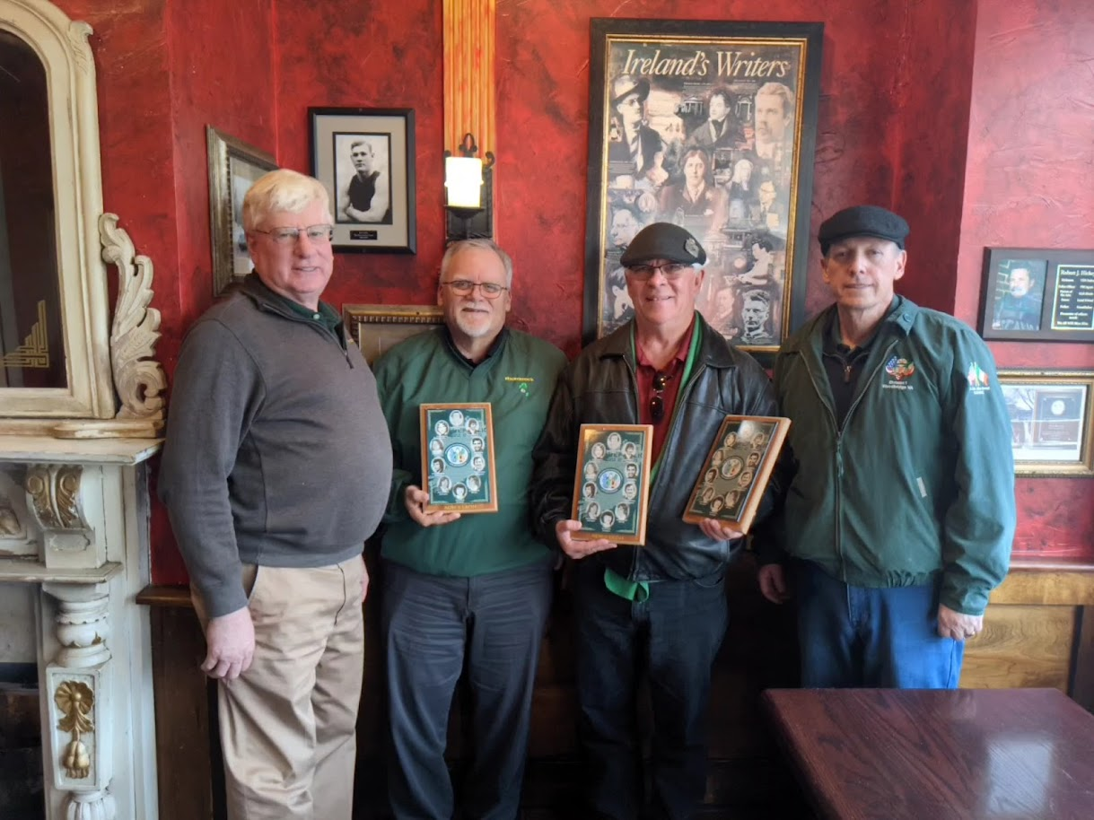

the 1st Cunningham gathering (held at OLOH ) got off to a rocky start when I botched the ZOOM meeting option! From what I have found out, there were about 5 Brothers who could not participate because of my screw-up. We did have 18 Brothers in physical attendance that evening. That translates to 23% in total or 18% in person of OUR total membership on hand for OUR monthly meeting. With this in mind, I encourage all Brothers to make a conscious effort to join OUR meetings, at least occasionally, to learn 1st Hand what is going on with YOUR Division. We keep the business portion of the meeting as relevant/short as possible to allow for amble time for THE GOOD OF THE ORDER - fraternity among Brothers, a shot and a toast or two of some delicious refreshments, a raffle, and a fair amount of wholesome Irish bantering! Please come and join us! We will be hosting the Shamrock Degree at the next Division meeting – February 9th!

On Thursday evening, January 20th, AOH Brother Fr. Anthony and I attended a gathering in Alexandria with many of the National Officers in town for the March for Life event to take place the following day. Hosted by the Herbert/Cady Division, the gathering of some many Hibernian brothers made for a great evening! FFAI National Director Martin Galvan singled our our State as well as our Division for its generosity to the annual FFAI campaign. VA came in 2nd only to NY and Cunningham Division led the State with its contribution! Thank you Brothers for your generosity and support. Pictured with Fr. Anthony is National AOH President Danny O’Connell

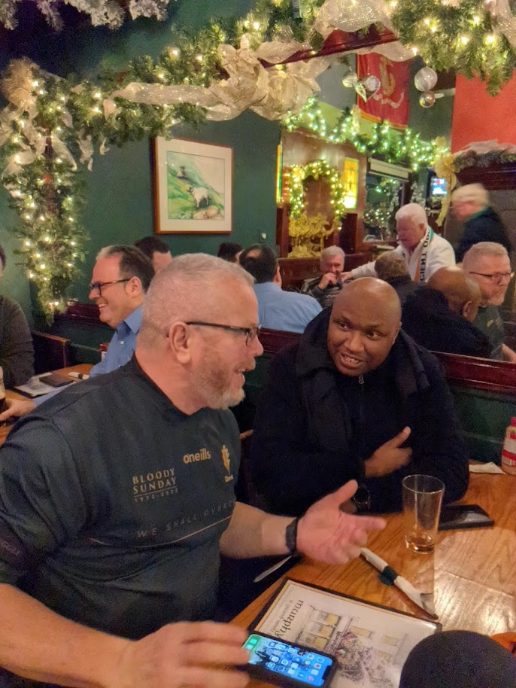

On Friday, January 21st, I represented OUR Division at the Annual March for Life in Washington, DC. Attendance was noticeably down from 2 years ago (ZOOM version only last year) due to COVID/cold weather concerns BUT THE ATTENDANCE AT THE AOH MASS PRIOR TO THE MARCH AT ST. MARY'S AS WELL FOR THE MARCH IN GENERAL BY OUR YOUNGER GENERATIONS WAS LARGE AND VERY ENCOURAGING! Candidly, more participation for this extremely important annual event by OUR Division in the upcoming years will be strongly encouraged. WE ARE THE VOICE OF THE UNBORN..... Yes, it was pretty cold that day – 18* - even for this boy from Upstate NY!

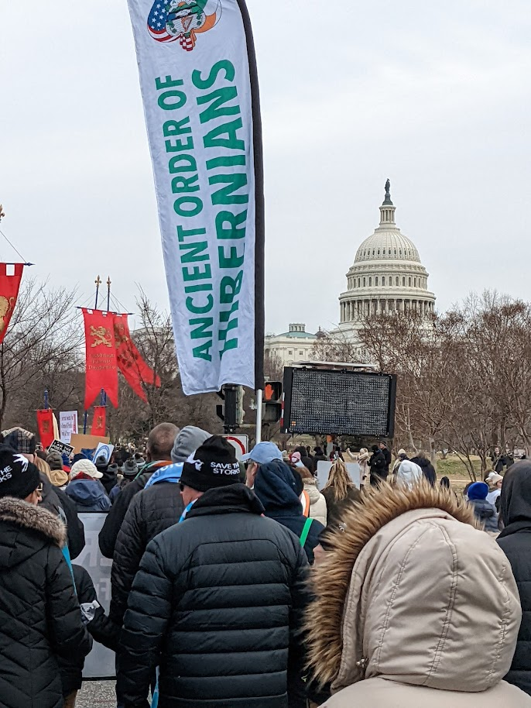
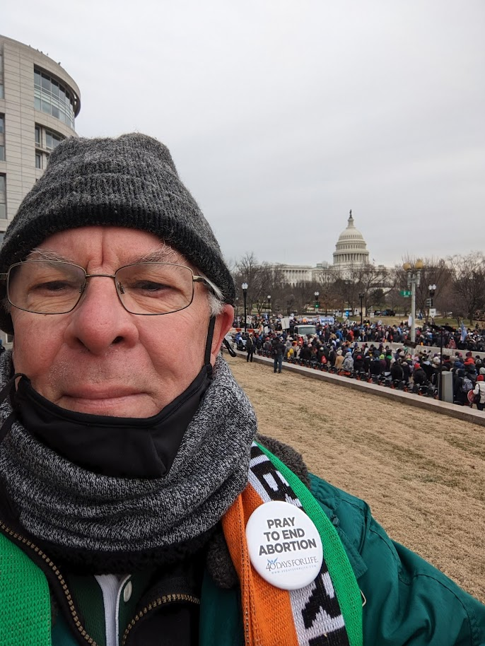

On Saturday, January 22nd, Brothers Bob Fay (VA AOH VP), Tim Melia (Div. Standing Committee Chair), Cole Slattery (Past Div. President), Bob Neiman (Div. Sentinel) and his son, and myself delivered over 600 nicely wrapped Sweat outfits, socks, cards and cash donations to the Martinsburg VA facility. Thank you Brothers! Facility Director Terry Stetler stated once again how much this annual event means to the veterans. We will start up this program once again in the fall. Thank you especially to Brother Tim Melia for coordinating our AOH efforts with the other groups – your are definitely “Christ in Action”!

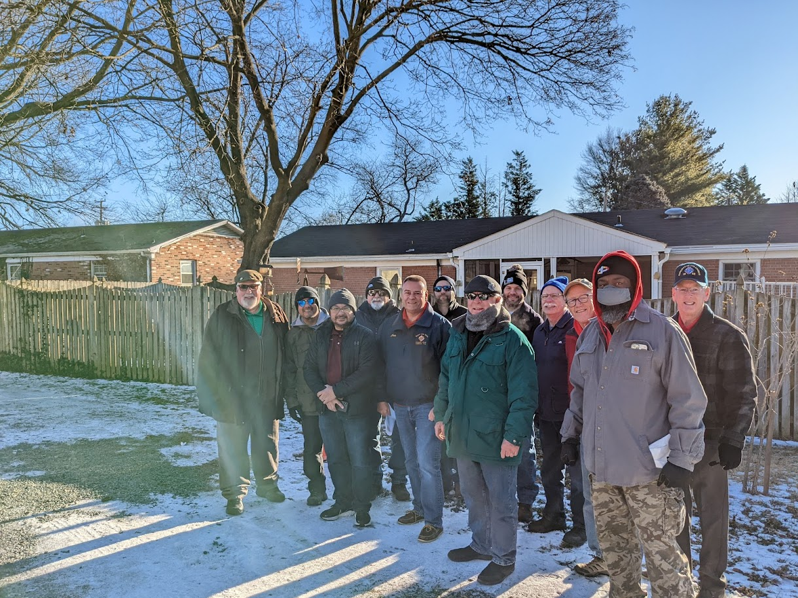

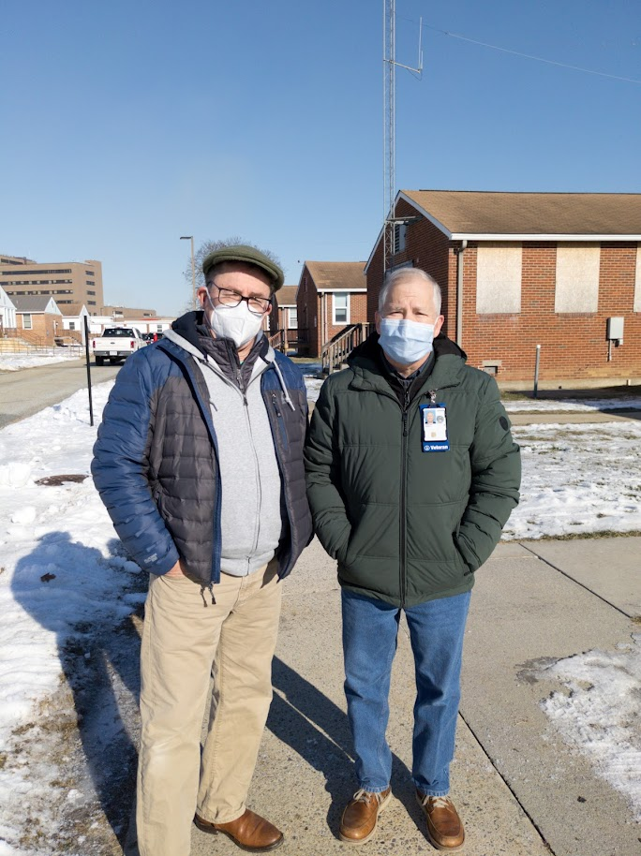

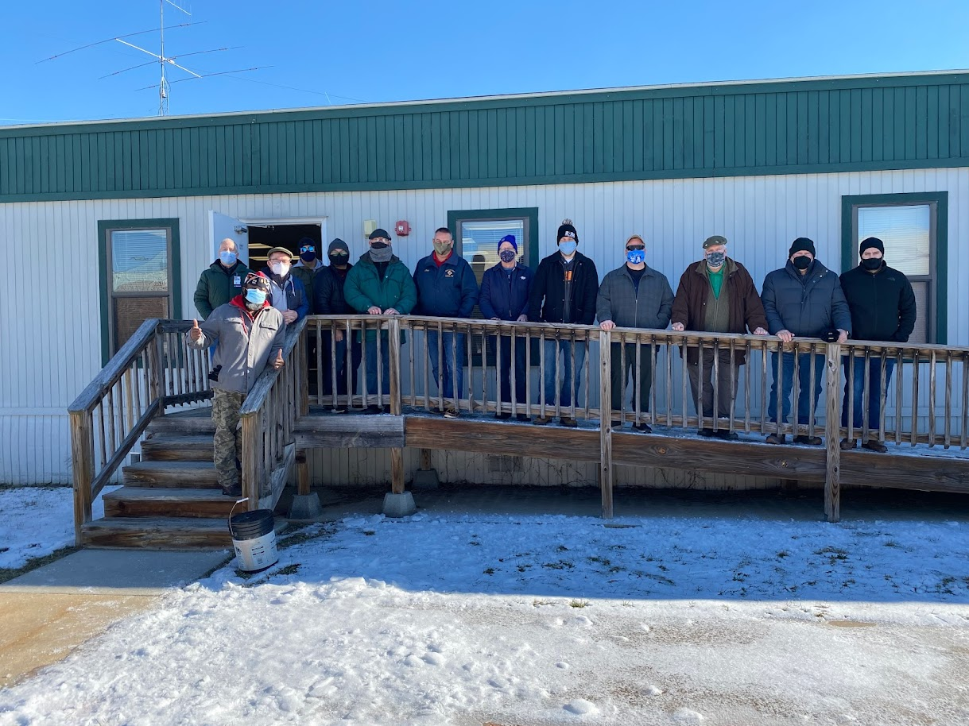

UPCOMING EVENTS

February 23, 2022 – March for Life in Richmond, VA with Bishop
February 26, 2022 – Next VA State Quarterly and Major Degree (tentative) – St. Jude in Fredericksburg
February 26, 2022 – KofC Annual Father/Daughter Dance at St. Joseph
March 2, 2022 – next Cunningham’s Officer’s meeting @ McCarthy’s Pub and Zoom
March 5, 2022 – Diocesan Men’s Conference at St. Joseph
March 5 – Alexandria Parade – POSTPONED TILL LATER
March 9, 2022 – Cunningham Division Business meeting @ OLOH at 7:30 (Zoom will be provided)
March 12 – Manassas Parade – application and sponsorship forms submitted
March 12, 2022 – KofC St. Patrick’s Party at OLOH – Division is not hosting its own party this year
March 14, 2022 – Gaelic Mass at the Cathedral

Slainte’

Jay
Cunningham Div. President
703 477-5934

